How To Download And Install Jenkins

Let’s get started.

Step 1: Download Jenkins  
Step 2: Install Jenkins

To download Jenkins, Go to ‘<https://jenkins.io/index.html>‘ and download correct package as per your OS.

[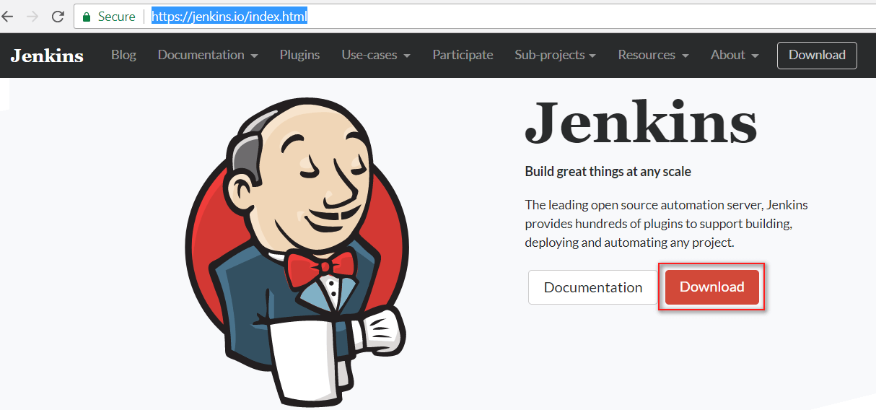](https://i2.wp.com/www.softwaretestingmaterial.com/wp-content/uploads/2017/08/install-jenkins-1.png?ssl=1)

I have downloaded Jenkins version 2.60.2

Unzip Jenkins to a specified folder. Right click on ‘jenkins.msi’ file and click on ‘Install’

[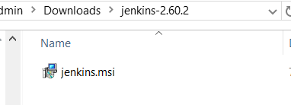](https://i0.wp.com/www.softwaretestingmaterial.com/wp-content/uploads/2017/08/install-jenkins-2.png?ssl=1)

Click on ‘**Next**‘ button

[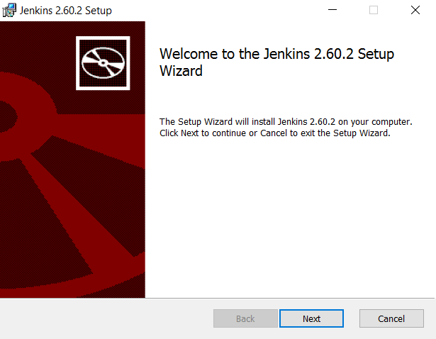](https://i2.wp.com/www.softwaretestingmaterial.com/wp-content/uploads/2017/08/install-jenkins-3.png?ssl=1)

Click on ‘**Next**‘ button

[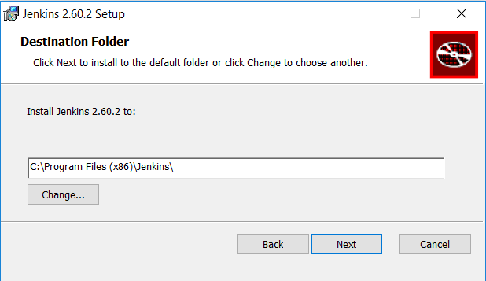](https://i1.wp.com/www.softwaretestingmaterial.com/wp-content/uploads/2017/08/install-jenkins-4.png?ssl=1)

Click on ‘**Install**‘ button to**install Jenkins**.

[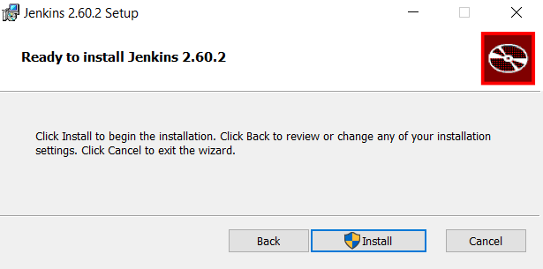](https://i1.wp.com/www.softwaretestingmaterial.com/wp-content/uploads/2017/08/install-jenkins-5.png?ssl=1)

Click on **Finish**button.

[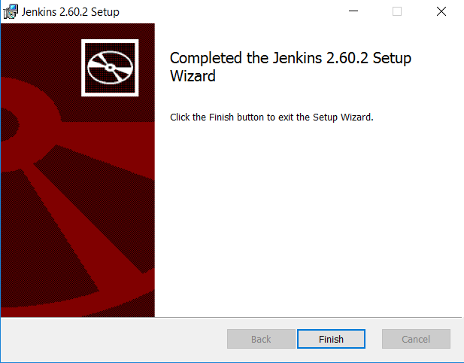](https://i0.wp.com/www.softwaretestingmaterial.com/wp-content/uploads/2017/08/install-jenkins-7.png?ssl=1)

Once the installation is done, navigate to the Jenkins Dashboard (http://localhost:8080 by default) in the browser window.

Copy the password from *initialAdminPassword* file and paste it. In my case the location is “C:\Program Files (x86)\Jenkins\secrets\initialAdminPassword”

[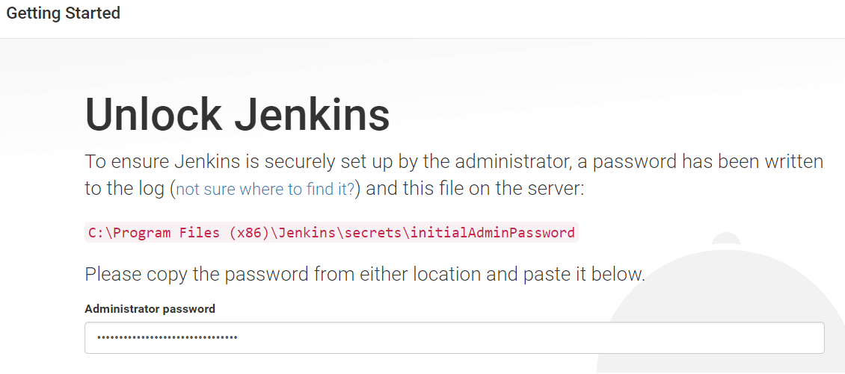](https://i1.wp.com/www.softwaretestingmaterial.com/wp-content/uploads/2017/08/install-jenkins-9.png?ssl=1)

Click on ‘**Install Suggested Plugins**‘

[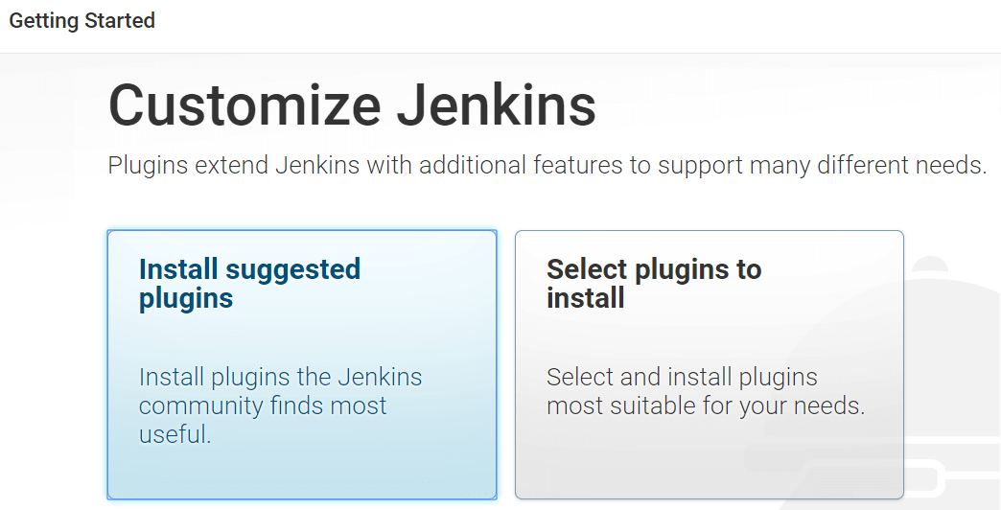](https://i1.wp.com/www.softwaretestingmaterial.com/wp-content/uploads/2017/08/install-jenkins-10.png?ssl=1)

Create an **Admin** user by giving Username, Password, Full Name and Email Address of your preference.

[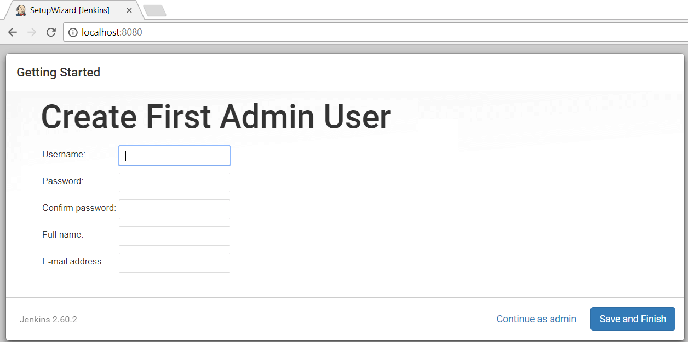](https://i1.wp.com/www.softwaretestingmaterial.com/wp-content/uploads/2017/08/install-jenkins-11.png?ssl=1)

This way we could Install Jenkins in Windows.

Set Up:

Pre Requisite: Maven Project should be present in Eclipse.

URL to host Jenkins: <http://localhost:8080>

Click on Jenkins --🡪Manage Jenkins 🡪Global Tool configuration and set JDK path .

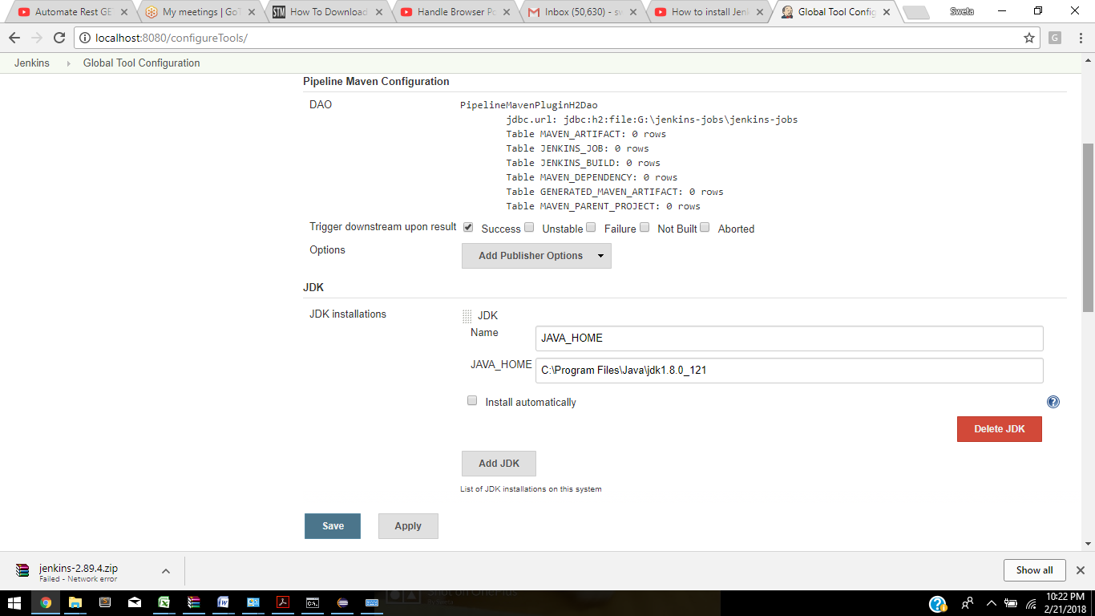

Click Manage Jenkins 🡪Manage Plugin

Click available TABFilter and type Maven

**And check all the Maven related dependencies (Maven Integration plugin)**

**Test NG Results Plugin**

**Path of testng Results XML:**

**G:\MyWorkspace\MavenDemoTest\target\surefire-reports\testng-results.xml**

1. Click on New Item. Enter Item name and select Maven Project.

2.Configure the below:

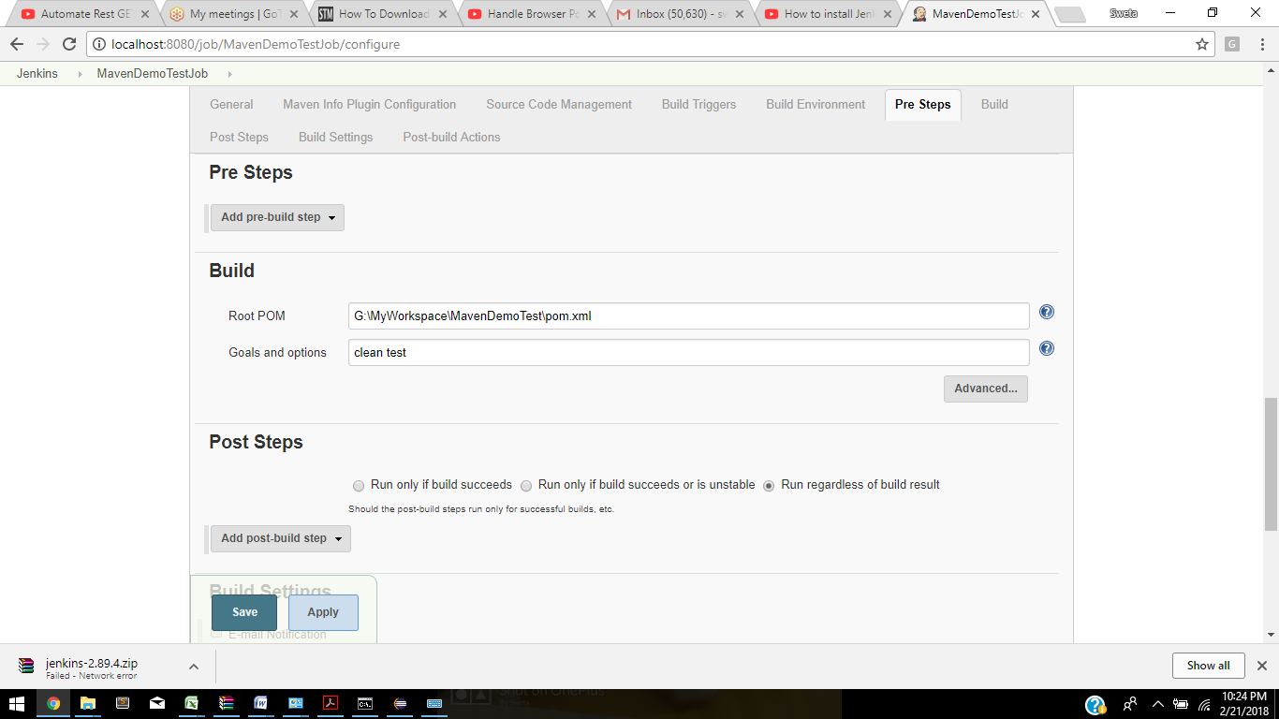

Click on Build Now:

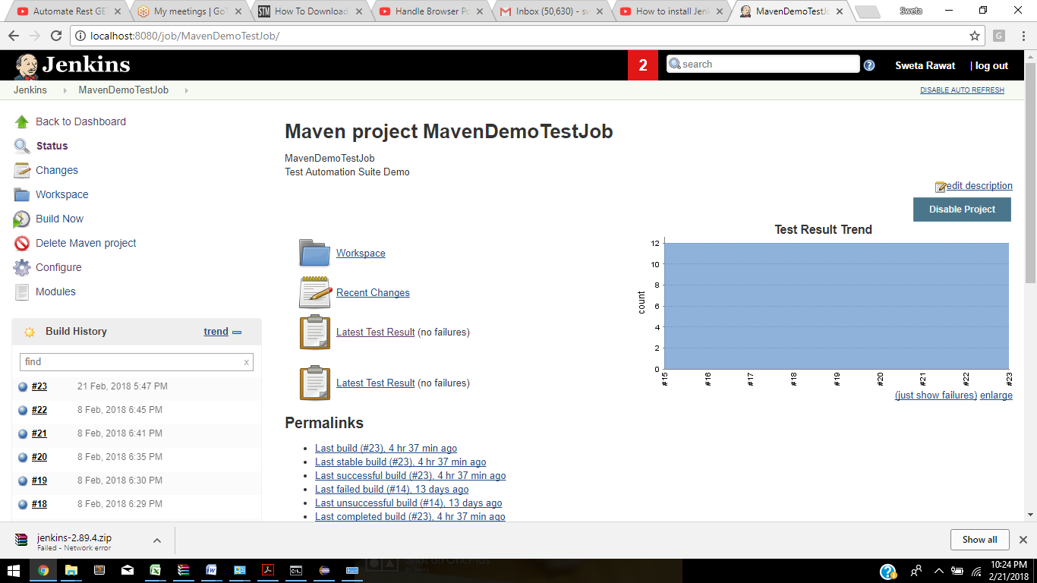

And check console Output

